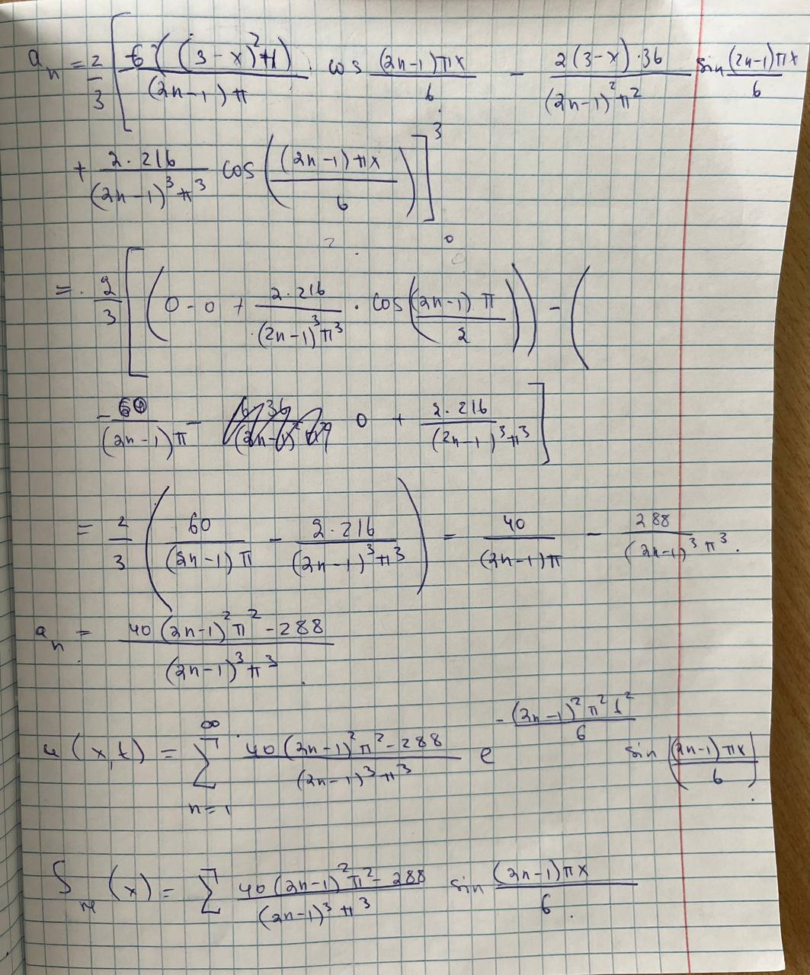Lab2 Nursagat Bikamal

